Insecticide

Naxypr Plus
Fast, powerful control of worms plus insects
Naxypro® Plus Insecticide is optimized to deliver powerful two-way control of lepidoptera and a range of other insects, leveraging the fast action and staying power of chlorantraniliprole and bifenthrin. Stop pest damage and sustain broad-spectrum control for up to three weeks. Flexible application rates and timing make Naxypro Plus a key tool for protecting yield through quick activity, just minutes after contact. Naxypro Plus provides excellent control of worms and other insects in corn, soybeans, cotton, canola, peanuts and tobacco.

COMPETITIVE ADVANTAGES AT-A-GLANCE INFO

Broad spectrum
- Controls a broad-spectrum of pests within minutes of contact
- Versatile resistance management tool
Wide application window
- Flexible application options

LEPIDOPTERA PESTS
EPA REG. NO. 71368-149
ACTIVE INGR. chlorantraniliprole (0.89 lb/
gal) + bifenthrin (1.33 lb/gal)
FORMULATION suspension concentrate (SC)
GROUP NO. 28 and 3A
MODE OF ACT. anthranilic diamide +
pyrethroid
REI 4 hours
SIGNAL WORD warning RESTRICTED no
PACKAGE SIZE 1 gallon (4 per case)

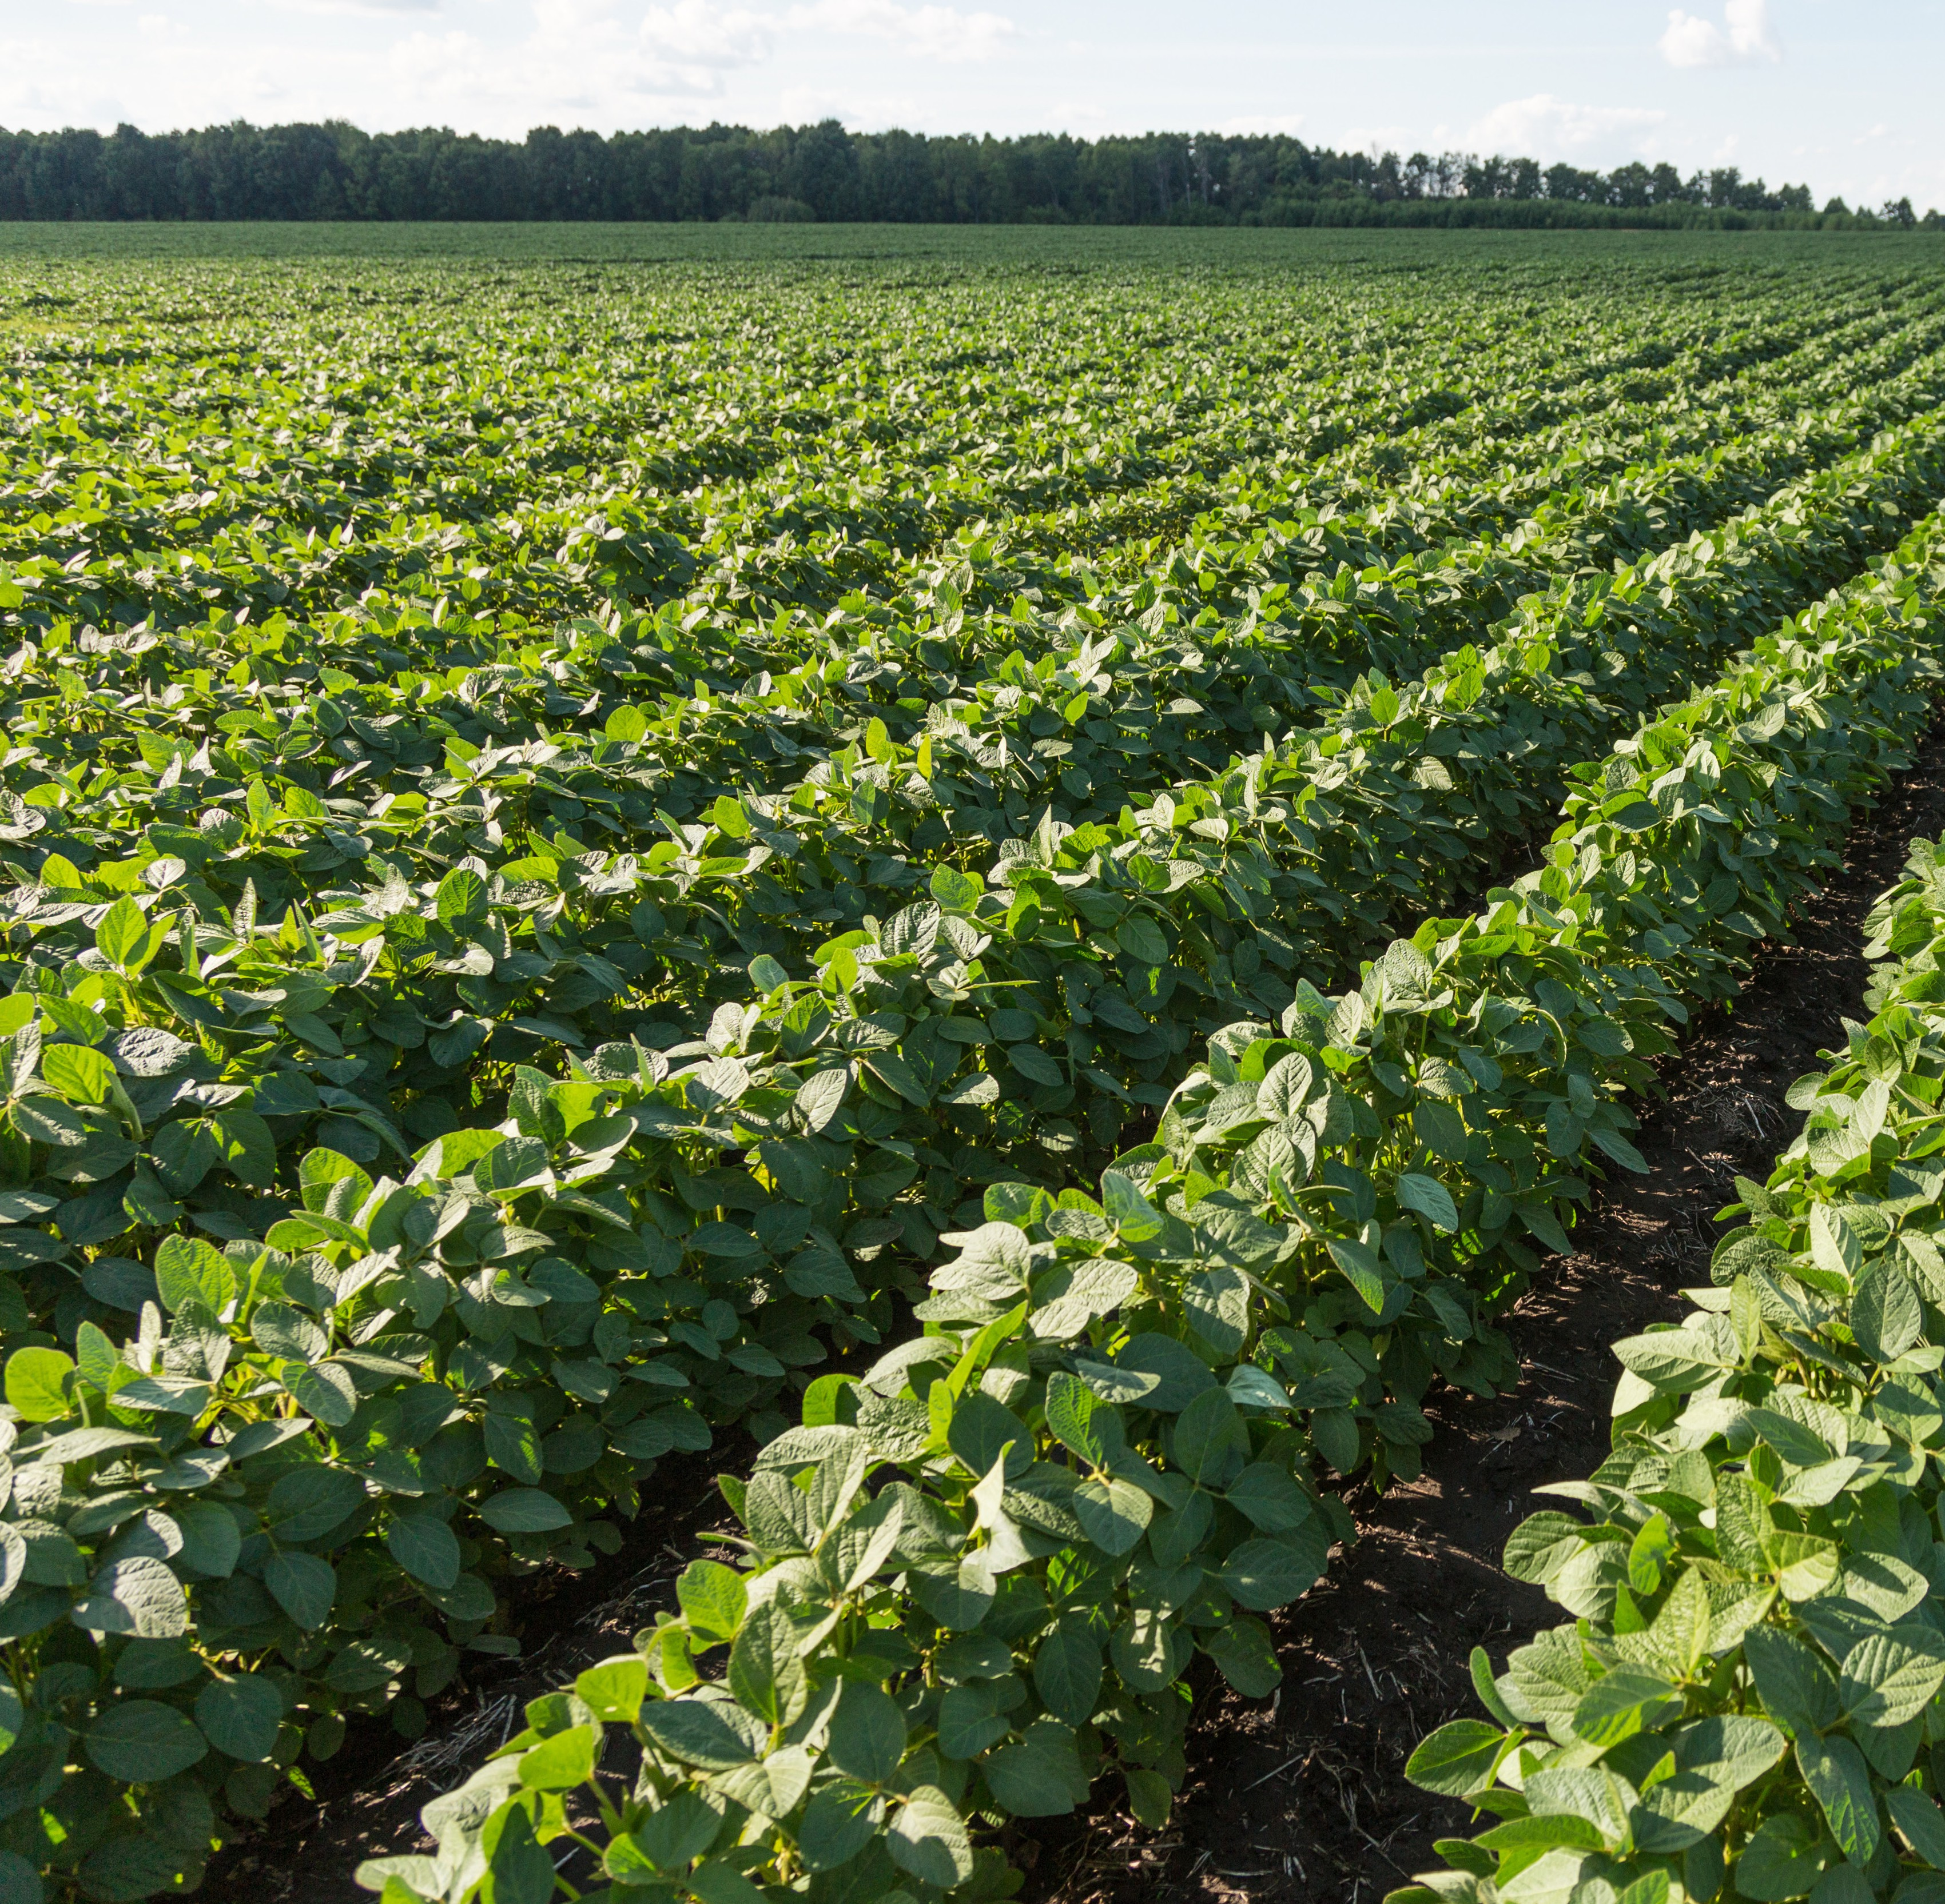




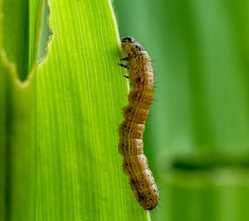
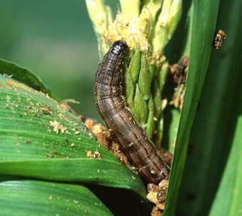
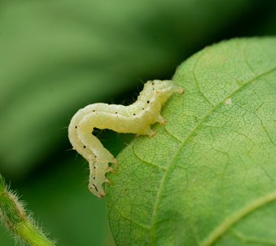
Armyworm Earworm Soybean looper

Naxypr
Plus
Fast powerful control of worms plus insects
KEY USES
USE SUMMARY

For use in broad acre crops including corn, cotton and soybeans.
*Not for use in California
**Not for use in California and Arizona
KEY PESTS CONTROLLED
(See product label for complete list)
Lepidoptera Pests Aphids Armyworms Beetles
Boll weevil Corn earworm Corn root worm Grasshoppers
Loopers (including soybean loopers) Stinkbugs
Thrips

nufarm.com/uscrop
Apply as a foliar application for broad spectrum control of lepidopteran insect pests as well as other listed chewing and sucking insect pests. It is a mixture of bifenthrin, belonging to the pyrethroid class of chemistry, and chlorantraniliprole, an anthranilic diamide class of insecticides with a novel mode of action acting on insect ryanodine receptors. Naxypro Plus has contact and ingestion activity, but it is most effective through ingestion of treated plant material
See label for complete application precautions.
APPLICATION RATES

CROP | PESTS | RATE | PHI | REI
Corn | Grasshoppers, aphids, beetles, chinch bug, corn rootworm adults, cutworms, green- bug, stinkbugs, tarnished plant bug, corn earworm, common stalk borer, armyworms, European corn borer, webworms, mites | 4.8-9.6 oz/A | 30  days | 12  hours
Cotton | Boll weevil, aphids, thrips, cotton fleahopper, cotton leafperforator, cutworms, grasshoppers, stink bugs, armyworms, loopers, cotton bollworm, tobacco budworm, lygus, mites, whitefly | 4.8-9.6 oz/A | 21  days | 12  hours
Peanuts | Cutworms, green cloverworm, grasshoppers, leafhoppers, southern corn rootworm, stink bugs, rednecked peanut worm, threecor- nered alfalfa hopper, velvetbean caterpillar, loopers, corn earworm, armyworms, tobacco budworm, aphids, mites, whitefly | 4.8-9.6 oz/A | 14  days | 12  hours
Soybeans | Aphids, beetles, loopers, corn earworm, corn rootworm, cutworms, false chinch bug, grasshoppers, green cloverworm, stinkbugs, leaf skeletonizer, leafhoppers, caterpillars, seedcorn maggot, spittlebug, hoppers, armyworms, European corn borer, lesser stalk borer, silverspotted skipper, webworm, tobacco budworm, lygus, whitefly, mites | 4.8-9.6 oz/A | 18  days | 12  hours




Before applying any Nufarm product, confirm that it is registered for use in your state. For specific application rates, directions, mixing instructions and precautions, read the product label. Please visit www.nufarm.com/uscrop to download a full label.
Insecticide
©2025 Nufarm. Important: Always read and follow label directions. 24-BA-0007


VIEW LABEL

